This is the first entry of many concise programming tutorials. They will serve as a good benchmark for a new programmer. **Initialize a Node.js project:**

1. Create a folder in your OneDrive to begin working on your project. (ensure you name it something relevant to make it easier to search for later)
2. You can initialize your project using two different methods. You can either use Command Prompt (CMD) or a batch file. If you decide to use the first option, you can do this by right-clicking “node_tutorial” and selecting “copy address”. In CMD Prompt, type in “cd” and paste in the address using “ctrl + V”.

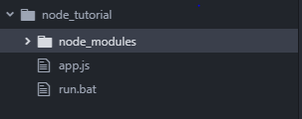

1. For the second option, you must create two new files: app.js and run.bat.
2. Regardless of the method, run “npm init”. (*in “run.bat” and CMD Prompt) this will create a package.json file.
3. 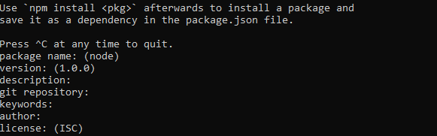Press enter and edit the package.json file to your liking.
4. You’ve successfully initialized a node.js project!
5. To run your app.js, change “npm init” to “node app.js” – do this regardless of the method you chose to use.